Name: Madireddy Mahesh

Batch: March 1st 2022

Tutor : Raham Shaik

Project Name: Automation Deployment Using Jenkins

* **Automation Deployment Using Jenkins:**

1. **Create 2 Ec2 instances one is for Jenkins and another one is for Tomcat server**
2. **Connect through putty**
3. **In one server configure Jenkins**
4. **In another server configure Apache Tomact**
5. **To install Apache Tomcat we have to get Repos from Tomcat website.**

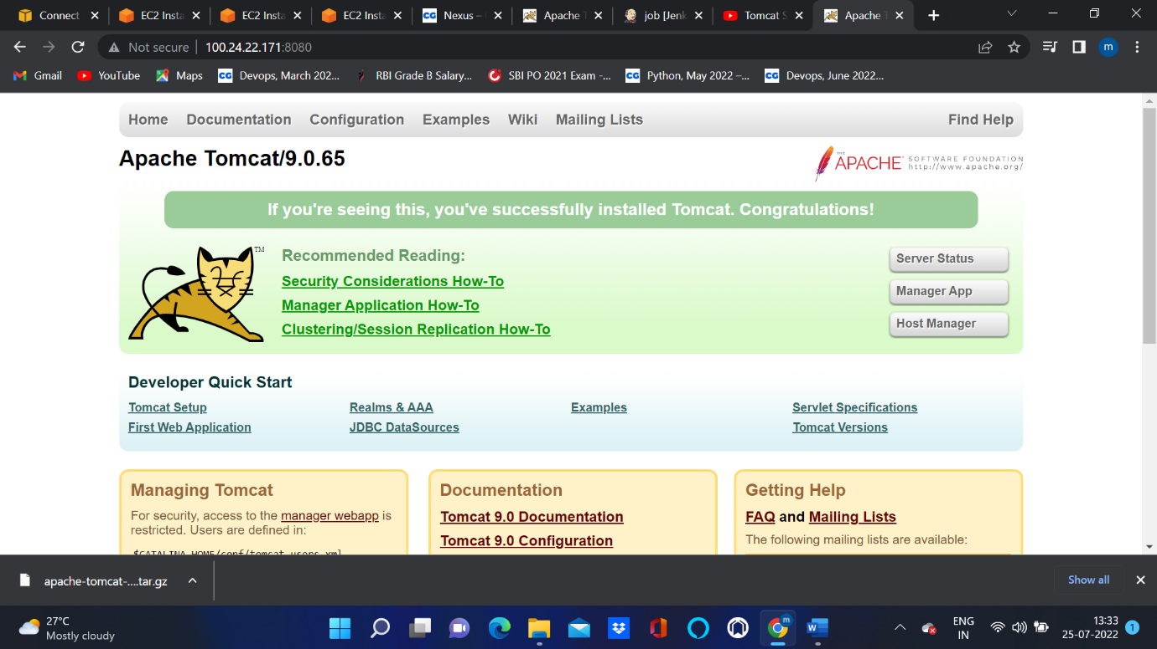

1. **Copy link of zip file and install Tomcat repositorys.**
2. **Configure Jenkins in another Server .**

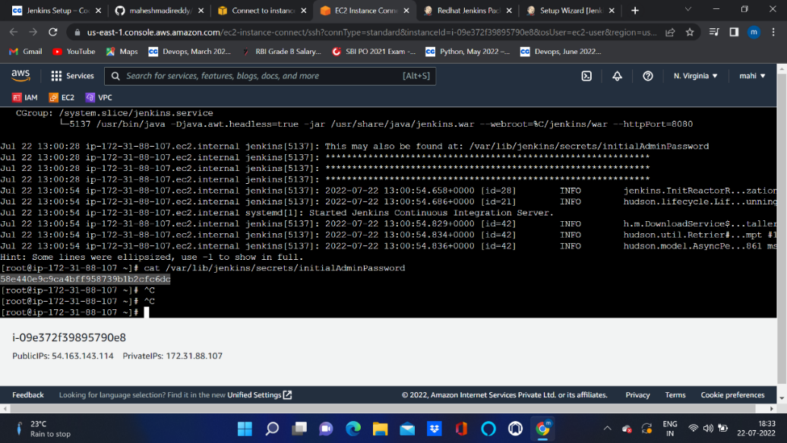

1. **After configuration copy public ip of server and paste into new tab(public:8080)**
2. **Install plugins**
3. **Login to Jenkins Dashboard**
4. **In another instance give full permissons to webapps directory.**

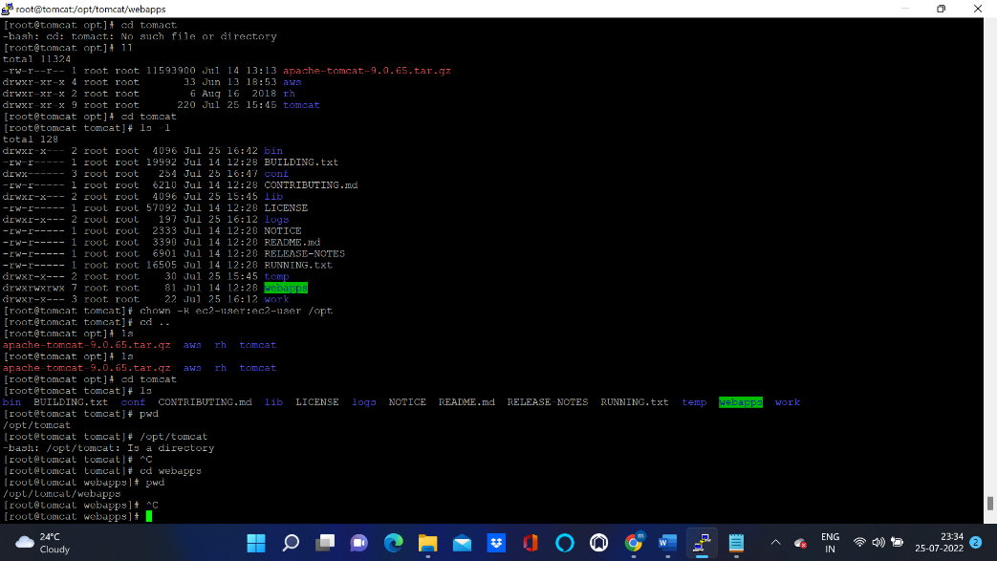

1. **In tomcat directory go cd conf and in that open vim tomcat-users.xml file and give username and password details and save (:wq!)**
2. **In tomcat directory go to cd bin and in that give (./startup.sh )command.**
3. **Now connect to Tomcat server by using (public ip:8080)**



1. **Go to manager App and give your credentials.**

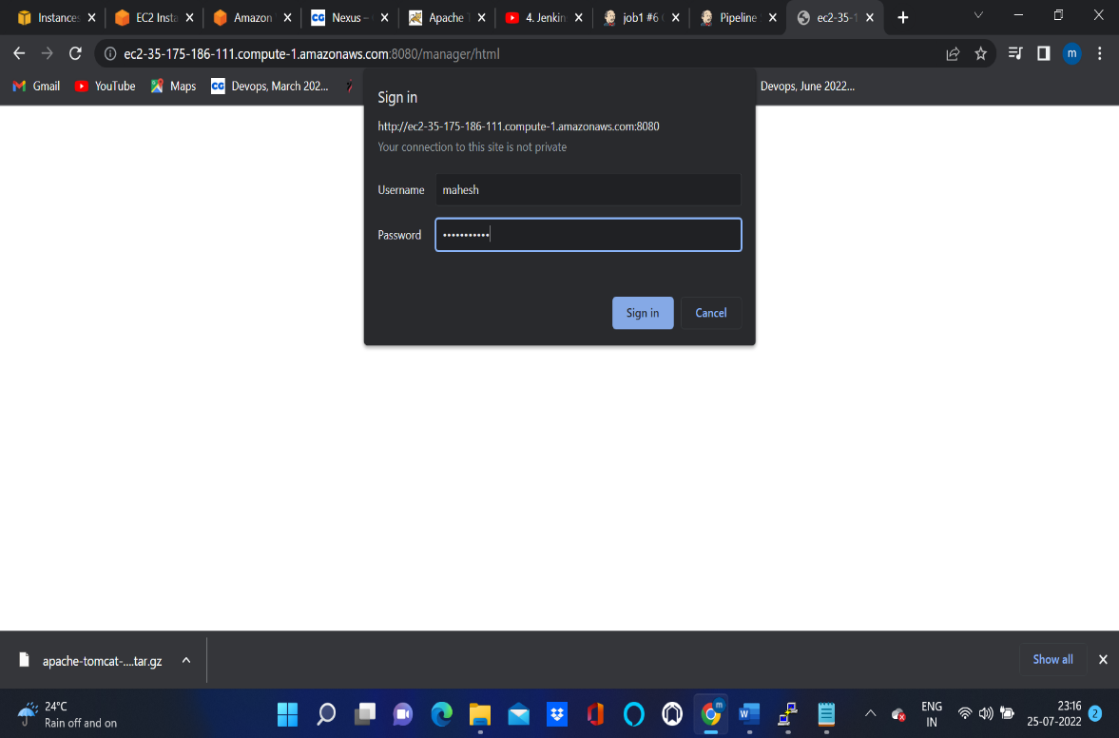

1. **In Jenkins Dashboard Create one pipeline Job.**
2. **Write pipeline Script in Declarative Format.**

**pipeline {**

**agent any**

**environment {**

**PATH = "$PATH:/opt/apache-maven-3.8.2/bin"**

**}**

**stages{**

**stage("git"){**

**steps {**

**git 'https://github.com/ravdy/hello-world.git'**

**}**

**}**

**stage("build"){**

**steps {**

**sh 'mvn clean install'**

**}**

**}**

**stage("deploy"){**

**steps {**

**sshagent(['deploy_user']) {**

**sh "scp -o StrictHostKeyChecking=no webapp/target/webapp.war ec2-user@35.175.186.111:/opt/tomcat/webapps"**

**}**

**}**

**}**

**}**

**}**

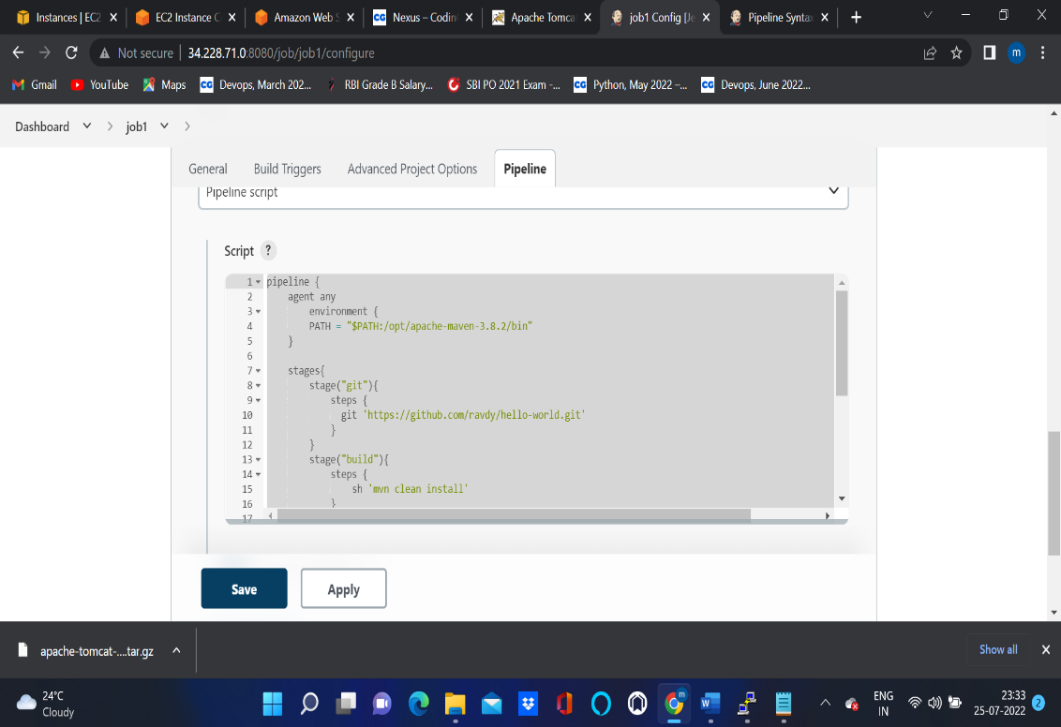

1. **Click Save and Apply**
2. **Now Build pipeline job**

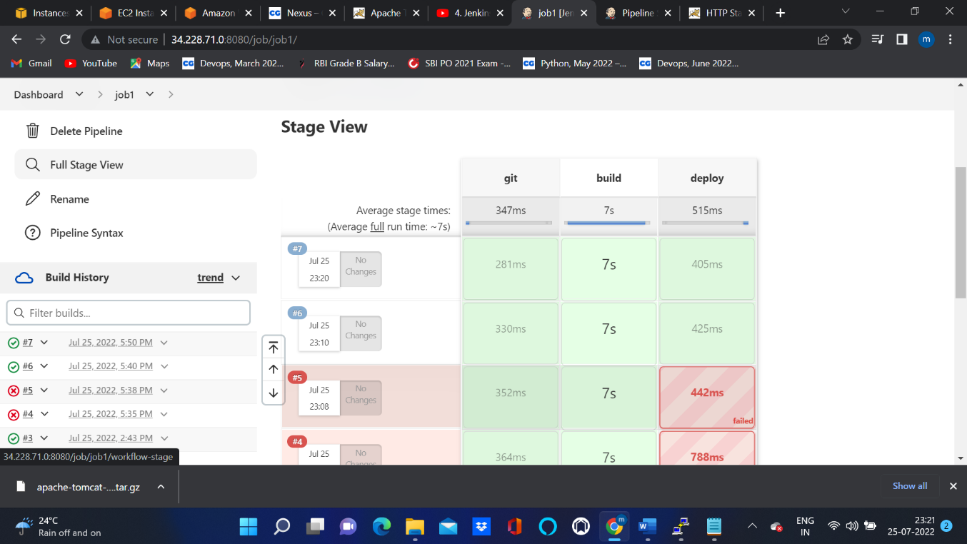

1. **Go to console output**

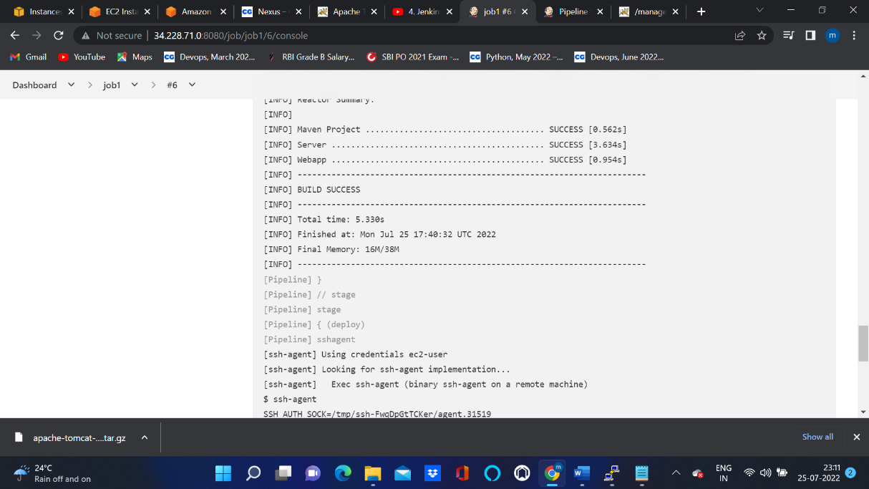

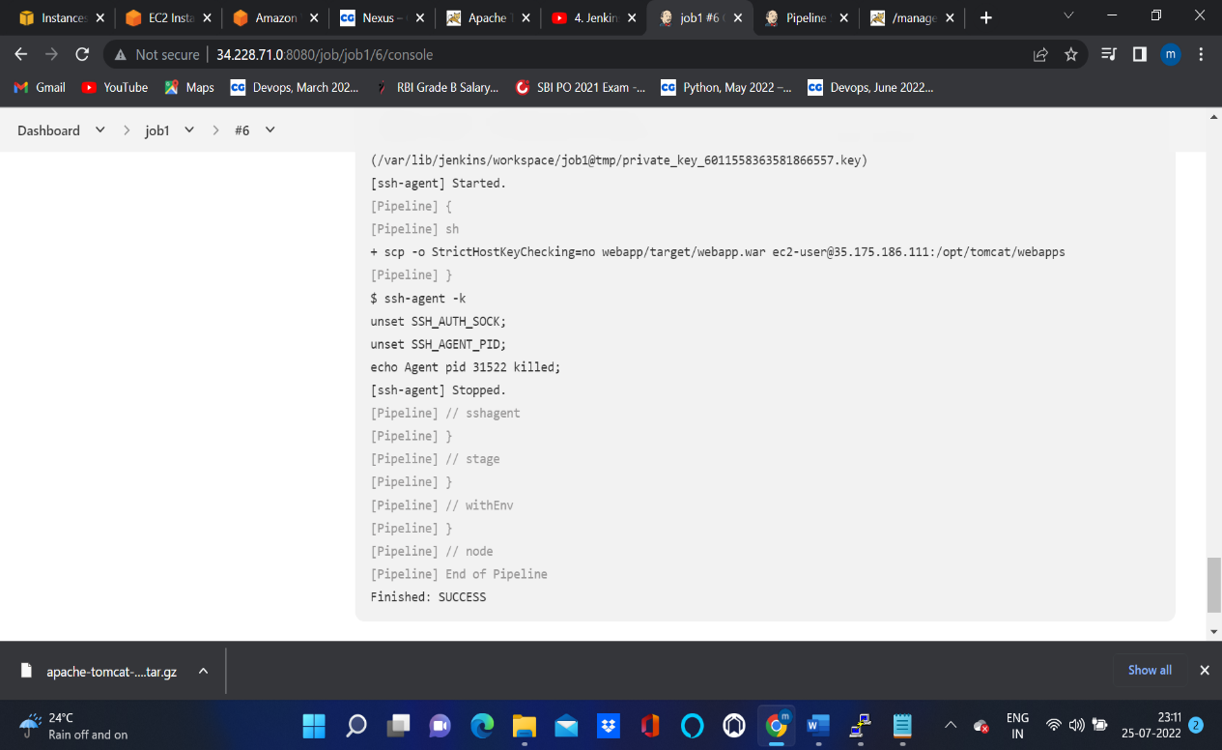

1. **Now check by giving url**

